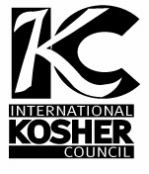
International Kosher Council
An Orthodox Kosher Supervision Center City, Philadelphia Division
484-857-2177 ikcphilly@gmail.com
ד"בס

Expires 12/31/2023

CERTIFICATION

THIS IS TO CERTIFY THAT ALL THE FOODS PRODUCED AND PREPARED BY AND AT
20th Street Pizza
108 S. 20th Street
Philadelphia, PA 19103

ARE
Kosher Pareve (vegan)
AND UNDER SUPERVISION FOR ALL YEAR EXCLUDING PASSOVER.

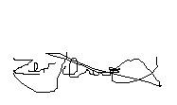THIS CERTIFICATION EXPIRES DECEMBER 31, 2023 AND IS SUBJECT TO RENEWAL AT THAT TIME.

RABBI ZEV SCHWARCZ

