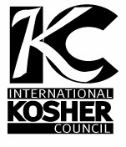
International Kosher Council
An Orthodox Kosher Supervision Center City, Philadelphia Division
484-857-2177 ikcphilly@gmail.com
ד"בס

CERTIFICATION

THIS IS TO CERTIFY THAT ALL THE FOODS PRODUCED AND PREPARED BY AND AT
Goldie (Fishtown)
1601 N. Front Street
Philadelphia, PA 19122

ARE
Kosher Pareve
AND UNDER SUPERVISION FOR ALL YEAR EXCLUDING PASSOVER.

PLEASE NOTE:
ALCOHOLIC BEVERAGES ON THE REGULAR MENU OR SERVED AT SPECIAL EVENTS ARE NOT UNDER SUPERVISION BUT DO NOT AFFECT THE KOSHER STATUS OF THE FOOD PRODUCED & SERVED AT THE RESTAURANT.
FOR KOSHER STATUS OF SPECIFIC ALCOHOLIC BEVERAGES REFER TO THE SEPARATE ITEMIZED LIST.

THIS CERTIFICATION EXPIRES DECEMBER 31, 2022 AND IS SUBJECT TO RENEWAL AT THAT TIME.

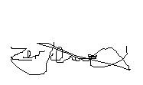 RABBI ZEV SCHWARCZ

