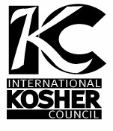
International Kosher Council
An Orthodox Kosher Supervision Center City, Philadelphia Division
484-857-2177 ikcphilly@gmail.com
ד"בס

January 1, 2021

CERTIFICATION

THIS IS TO CERTIFY THAT ALL THE FOODS PRODUCED AND PREPARED BY AND AT

Luhv’s at Reading Terminal Market
51 N. 12th Street
Philadelphia, PA 19107

ARE
Kosher Pareve
AND UNDER SUPERVISION FOR ALL YEAR EXCLUDING PASSOVER.

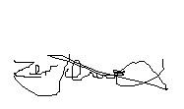THIS CERTIFICATION EXPIRES DECEMBER 31, 2021 AND IS SUBJECT TO RENEWAL AT THAT TIME.

RABBI ZEV SCHWARCZ

